About Me

**Dr. Himanshu Aggarwal (Ph.D.), MRSC.**

*Dr. Himanshu Aggarwal* did his *Ph.D.* in supramolecular chemistry from *Stellenbosch University*, South Africa, under the supervision of *Prof.* *Len Barbour*. During his Ph.D. he worked on studying structure-property relationships of flexible metal-organic frameworks (MOFs), change of interpenetration in MOFs and its effects on gas adsorption, in-situ gas modelling in MOFs and thermal expansion in MOFs. Following his Ph.D. he moved to the research group of *Prof. Mohamed Eddaoudi* in King Abdullah University of Science and technology (*KAUST*), Saudi Arabia for his postdoc where he worked on designing rigid MOFs for gas separation, storage and sensing. Besides that he also worked on designing MOFs for controlling indoor humidity.

**Educational Details**

Ph.D. (2015) – Stellenbosch University, South Africa.

MSc. Chemistry Honors (2010) – Guru Nanak Dev University, Amritsar, India.

**Professional Experience**

Postdoctoral Fellow (2016 - 2019) – AMPM Center, King Abdullah University of Science and technology (*KAUST*), Saudi Arabia.

Postdoctoral Fellow (2016) – Stellenbosch University, South Africa.

**Journal Reviewer**

1. Journal of Material Chemistry A
2. Crystal Growth & Design
3. Molecular Systems Design & Engineering

**Highlighted Publications**:

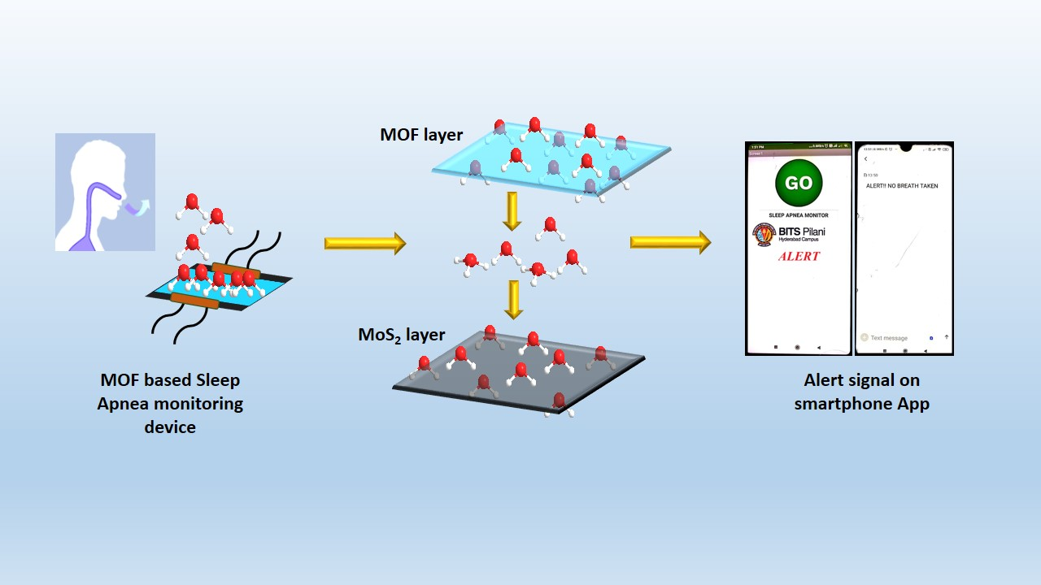

Exploration of MOFs for healthcare applications has been limited to date. We have explored a Cu based MOF for preparing an electronic breath sensor for sleep apnea diagnosis. The MOF-MoS2 hybrid device shows excellent response time and precision. An android based smartphone app has also been prepared for real time monitoring.

***J. Mat. Chem. B***, **2020,** 8, 10182.